**Experience *The Night Watch*, Contextualize An Exhibit:**

**How Digital Augmentation Is Transforming Museum Space**

*by Sasha Solovyeva*

A Senior Thesis Submitted to the Department of Media, Culture, and Communication

New York University, New York

Advisors: Finn Brunton and Marita Sturken

May 14, 2021

**Abstract**

The nature of museum is accelerating, and new forms of collection organization are appearing to mediate a more experiential and participatory visit. This study looks at how juxtapositions and montages of exhibits, rather than conventions of physical space, help dynamically re-contextualize the collection. Digital augmentation is critically examined through the lens of meaning-making: does a museum use new media technology to simply mirror an analog visit, or does it allow the novelty and uncertainty of augmentation to inform and reform their approach? Two cases of efficiently augmented browser-based museum tours – “Masterpieces Up Close” by the Rijksmuseum and “The Museum of the World” by the British Museum – are brought into the study to demonstrate internal and external elements of a visit that can be used to construct constellations of contexts and ideas. The analysis of these two examples, contrasted to one instance of an inefficiently augmented exhibition, attempts to show to the reader that non-spatial digital architecture affords a museum the capacity to contextually augment the collection as well as construct a narrative of self-discovery that is conducive to unintentional augmentation. I suggest that Benjamin’s juxtaposition-based assessment of history, Eisenstein’s perception of cinematic montage as a basis for intellectual thought, and the ideas of intentional and unintentional augmentation can be used as a framework for studying the transformation of the modern museum as an institution.

**Introduction**

*“The democratic surround was not only a way of organizing images and sounds;*

*it was a way of thinking about organizing the society.”*

*–* Fred Turner, “The Democratic Surround”

If one was tasked with setting up a museum exhibition, how would they go about it? Paintings evenly hung on white walls, sculptures mounted on cubic pedestals, small golden plaques attached to every artifact announcing their makers and dates of creation – there is a set of conventions of spatial organization connected to the very concept of Western Museum.

Although museums have been investing significantly in virtual experiences, especially as they were forced to shut down in-person visits due to COVID-19 (Grant), they largely hold onto familiar patterns of organizing a collection. However, a case for less anachronistic approaches in museums’ virtual experiments and beyond is being made more and more, often by criticism of the lack of inclusivity, accessibility, and diversity. As a debate on whether removing admission fees directly attracts larger audiences remains unsettled, many agree that it is the space itself – rigid, with the weight of colonialist history, sometimes overtly complicated – that makes the museum unwelcoming (Olivares and Piatak). There is no consensus as to exactly how museum space can change but virtual media have a lot of potential to bring disruption into entrenched conventions of museum-going (Glinka 92).

Most digital media used by museums such as Virtual Reality (VR) or website catalogs are not spatial in nature. In theory, this allows curators to reimagine a museum’s collection in any number of ways when they transform it for the digital medium. Yet, an overwhelming number of digitized collections do not reflect any visual, semantic, or contextual changes from their analog counterparts. This is not surprising – as media theorists such as Siegfried Zielinski wrote, a new form of media (e.g., television) always originally relied on media that preceded it (e.g., cinema and radio) before finding its unique form (Zielinski and Custance 11).

What media forms do museums invent and capitalize on when they depart from conventions of an analog spatial organization? In this study, I use a theory of juxtaposition by Walter Benjamin and a theory of montage by Sergei Eisenstein to analyze an augmented museum experience. Since both thinkers had contemplated a role of a *transition* between two parts of a whole, I look at the role of transitions between objects of a museum collection in the digital space. The goal of this study is to answer a question: how do museums juxtapose and montage a collection to *efficiently* augment their narrative? What I argue is that utilizing non-spatial digital architecture affords a museum the capacity to capitalize on a combination of *intentional* and *unintentional* augmentation.

The general definition of augmentation as “to make greater, more numerous, larger, or more intense” (“augment”) adequately determines how the term is used throughout this study. More precisely, whenever augmentation is mentioned in this thesis, it should be understood as digital augmentation, i.e., an expansion of museum experience digitally. The caveat on digital augmentation is important because it indicates that “augmentation” is not used as a qualitative term. Any experience, whether augmentatively efficient or inefficient, will be described as “augmented” to denote the role of technology in reshaping transitions in a museum collection. It does not, therefore, imply contextual augmentation – augmentation of meaning or context. To recognize digital augmentation that relies on an experimental process to convey an associative, holistic, and contextual way of perceiving museum objects, I have decided to use the term *efficient augmentation*. Digital augmentation can be recognized as efficient if it provides the user with new contextual capacities and modes of engagement with art. A contrast between *efficient* and *inefficient* augmentation helps drive a point that not every attempt to wrap museum artifacts in cutting-edge technology is successful from the perspective of engaging a visitor.

Another important dichotomy that exists within the concept of augmentation is that of *intentional* and *unintentional* augmentation. I have crafted these terms to make a distinction between juxtapositions and montages that are curated and narrativized by a museum, and those that happen outside of its control. An example of intentional augmentation is a navigation system in a browser-based VR that affords “jumping” between museum paintings. An example of unintentional augmentation is a narrative that directly or indirectly points at art approaches and forms that a museum object has inspired.

The dispersion of applications of digital augmentation by museums is vast, from social media to documentary films to different forms of audio guides. In this study, I only considered museum experiences that are exclusively virtual (without an in-person component) and are purposefully built for access in a web browser. This means that only interactive experiences, i.e., the ones requiring user input and participation, were considered in this research. This choice derives from three main reasons. Firstly, museums’ presence on the web tends to be entirely free and available to anyone with a computer. In contrast to in situ Augmented Reality or mobile applications that are only downloadable on a limited number of devices, browser-based museum content is theoretically open to the broadest and most diverse audience. Secondly, due to its ubiquity, the web-based approach tends to pose the biggest number of technical difficulties and limitations. Since slow internet connections, outdated device systems, and user experience on different devices have to be heavily accounted for, some web experiences readily give away their lack of context or adaptability. Lastly, online museum tours use the widest range of multimedia available to museums, including AR, VR, video, photography, imaging, audio, etc.

Based on these criteria, I analyze juxtapositions and montages through two vastly different examples of virtual museum experiences. The first one is a VR experience “Masterpieces Up Close”[1] that renders the Rijksmuseum’s Gallery of Honor in 3D. I specifically focus on the augmentation of the most famous artwork in the gallery, Rembrandt van Rijn’s *The Night Watch.* “Masterpieces Up Close” experience was chosen for two reasons, primarily because it implements a complex web of new media technology that presents a layered image of a museum’s augmentation. The other reason has to do with the subject matter of the Gallery, the Dutch Golden Age artworks of the 16-17th century. This “traditional” museum space with rows of large paintings that looks very detached from digital technology might have come into conflict with the manifold dynamic augmentation of “Masterpieces Up Close” – but instead the digital and non-digital parts of the visit work in synthesis.

The second object of this research is the British Museum’s interactive experience “The Museum of the World”[2]. Subverting what we might expect from visiting a museum online, this exploration tool allows us to scroll through a multi-century timeline to serendipitously discover objects from the museum’s many collections. Denoted as small colorful spheres, exhibits are not presented in terms of what they are but instead in terms of how they are connected. Following the ethos established by the museum, in my analysis, I do not single out an exhibit and instead, look at how augmentation encourages a search for inter-exhibit connections. I have selected this exhibition due to its radical rejection of conventions of physical architecture, forming a stark contrast to “Masterpieces Up Close”.

The main method of this study is an analysis of different applications of augmentation in “Masterpieces Up Close” and “The Museum of the World.” By looking in detail at their design implementation, I determine tools and approaches they use to efficiently augment their objects and evaluate these tools through theories of juxtapositions and montages. I also briefly contrast findings of the first method to inefficiently augmented museum experiences. This comparative method helps to come up with criteria for the success or failure of digital augmentation from the perspective of experimental efficiency.

To achieve the goal of this study, I start with a review of relevant literature that focuses on *The Arcades Project* by Walter Benjamin and *Notes for a General History of Cinema* by Sergei Eisenstein to show the crucial nature of juxtapositions and montages to the modern museum. I then transition to a comprehensive overview of augmented virtual experiences, classifying them based on much they hold onto physical conventions in displays of their collections. Afterward, Chapters II and III are dedicated to an in-depth analysis of the Rijksmuseum’s and the British Museum’s augmentation from a visitor’s perspective. To wrap up the study, the last chapter briefly looks at an example of inefficient augmentation by the Museum of Fine Arts in Ghent.

**Literature Review**

Two concepts that will help frame my analysis of augmentation are *juxtaposition* (Benjamin) and *montage* (Eisenstein). Since both Benjamin and Eisenstein were interested in film theory, they saw montage as a way of bringing historiography and time into a spatial dimension and putting events that happened at seemingly unrelated points of history in front of a viewer in a dialectical manner. Eisenstein regarded film as a medium to interpret all other art forms (86, 87).

In an early 21st century survey of Benjamin’s *Arcades Project*, George Dillon writes that things can be considered juxtaposed when there is “no connecting matter or continuing thread or common topic” between them but they still share some “inexplicit connection.” Benjamin writes that most elements in history can be considered juxtaposed to “a matter of degree,” meaning that they need to be evaluated in relative rather than absolute terms.

Benjamin expands on the idea of juxtapositions by introducing a more complex concept of “constellations.” Constellations go beyond merely reflecting *transitions* the way juxtapositions do and instead present “a configuration of fragments” (Dillon). This configuration is defined by its volatility because “a sudden clarification or new grasp of the import of the fragments can occur.” Constellations are notably dependent upon personal perspectives of onlookers; Dillon remarks that “readers from different times and different angles of view may see different constellations and different meanings.” A visual representation of Benjamin’s constellations as a non-metaphorical celestial sky object is a helpful way to understand the concept. The only significant distinction is that in Benjamin’s metaphor, each “star” of a constellation comes and goes depending on contexts and narratives; *volatility* is key.

One of the central aspects of Eisenstein’s work is the notion of a “montage of attractions,” originally crafted in the context of cinematography and theatre to describe “contrast, equivalence, recurrence, or conflict” of two intercut sequences (qtd. in Dyer287-288). There is, of course, a difference between film’s sequential quality of frames and the lack of linearity in constellations of non-moving images where narratives are constructed as one idea triggers next “irrespective of any hierarchy, chronology or duration” (Dillon). In my analysis, I focus on Eisenstein’s idea of an “intellectual montage,” one of five types of montage central to the Soviet Montage Theory. The intellectual montage is defined as “the juxtaposition of images of concrete objects to construct abstract concepts and notions, preferably through a conflict of meanings” (Hediger 352).

Both Benjamin and Eisenstein saw implications of montages for the history of thought. Eisenstein insisted that intellectual montage can be likened to intellectual thinking since both involve participation in “comparative activity” (*deiatelnost’ sopostavitelnaia*) (Somaini 87). In “On the Program of the Coming Philosophy,” Benjamin states that the only way we can define historical and intellectual truth is through temporal volatile relationships of elements in constellations (Ross 82).

What brings juxtapositions, montages, and constellations to the forefront of our discussion on an interpretation of an artwork? As Berger notes in *Ways of Seeing*, if a piece of visual media is left to “speak for itself,” it is the external context that defines our interpretation of it, not a maker’s intention (56). In this sense, my approach is centered around the relationship of these external meanings and our interpretation of an art object, which forms juxtapositions whether or not a museum intends them. Therefore, the meaning of an artwork is eventually derived from a negotiation between the viewer, the work, and the context in which it is viewed/interacted with.

New media technologies in museums augment these juxtapositions to a more significant extent than analog augmentation is capable of. Here, an overview of all forms of digital media used by museums is necessary. Claire Roederer, Robert Revat, and Jessie Pallud classify technical tools into two categories: “traditional forms of mediation,” namely guides, panels, labels, and audio guides, and “digital technologies” such as websites (to access catalogs but also to engage), mobile devices, RFID (Radio-Frequency Identification) and NFC (Near Field Communication) technologies, and Augmented Reality (108-110). To consider this list comprehensive for this thesis, I believe that Mixed Reality (MR) and Virtual Reality (VR) need to be included in the second category.

Augmented Reality (AR) is arguably the most well-known source of augmentation that museums have eagerly experimented with to a warm reception from audiences (Mohammed-Amin ii; Roederer, Revat and Pallud 108). Most examples this thesis considers do not use AR; however, this medium has received a lot of consideration and criticism that carry over to a larger conversation about issues of digital augmentation. In his criticism of AR as of 2018, Adam Greenfield points out that putting a device between one’s senses and the world disjoints from the phenomenological experience of the space, creates “social, spatial, temporal and experiential differences”, and destroys the “aura” as defined in early Benjamin’s works (Greenfield; Roederer, Revat and Pallud 109, 111). Greenfield also warns that “the information that is being furnished so authoritatively will simply be wrong” and “any augmentive (*sic*) mediator by definition imposes itself between the wearer and the world” (17, 13). A similar concern applies across different tools of augmentation, with some authors suggesting that curators need to be more aware of a massive influence they unknowingly embed into the very basics of code and design of an online experience (Wilson 375-376; Roederer, Revat and Pallud 110).

One of the aspects of Benjamin’s *Arcades Project* that makes the juxtaposition effect so apparent in the text itself is its “hypertext-like” quality (Dillon). A prime illustration of this quality in the 21st-century museum is a museum website with literal hyperlinks and other affordances that form immediate juxtapositions. Therefore, how a museum structures its website is crucial in how the user’s involvement in contextual augmentation will look like. When Ross Wilson studied the code of the British Museum’s online catalog, he concluded that its organization follows spatial patterns (Wilson 374-375; de Groot 93). Even authors who do not consider spatiality translating into digital representations a problem, still consider new media affordances important for visitor experience. For example, Jerome de Groot notes that access to objects in a horizontal rather than a linear/hierarchical manner is a distinctive strength of a museum website (93, 98). He also cherishes the ability to see more objects in less amount of time; this rapidity of experience is an example of juxtapositions/montages that can happen on any museum website. More radically reevaluating the purpose of a museum’s online presence, Antonio Battro writes that interacting with digital reproductions in unexpected ways is the ultimate strength of a museum without space (meaning a digital museum). To him, removing a museum object from its context is what lets it be perceived more clearly in relation to itself and other art. Battro compares a digital museum to a photograph that at its invention was seen as an inferior tool of portraying and representing museum collections. However, he writes: “A reproduction devoid of those essential attributes [color, material, volume, and dimensions] certainly cannot be like the original. … But thanks to this loss it also gains something. … It finds, says Malraux, … synchrony with other works that seemed unrelated to it.” (141-142) Battro sees this synchrony across works of a digitized museum collection as a necessary shaper of visual meanings. De Groot also writes about the “purity” of a direct relationship between visitor and artifact that can be achieved by decontextualization that Battro praises. However, de Groot sees two downsides to this perception: an illusion of authenticity of digital experience one inevitably develops (echoing Wilson’s and Roederer et al. concerns) and “noisiness” of more layers between a viewer and an item (echoing Greenfield’s criticism of AR’s disconnect from phenomenological experiences) (94).

Museum mission has also been studied and reassessed outside of the scope of digital media. Looking at criticism and praise of the modern museum helps understand pre-existing juxtapositions and montages that digital augmentation comes into contact with. Barbara Kirshenblatt-Gimblett’s work “The Museum – A Refuge to Utopian Thought” provides an interesting perspective on a “materialized subjunctive space” of a museum, which is seen by the author as a “contemporary utopian laboratory”. Kirshenblatt-Gimblett values juxtapositions, connections, and contrasts, all of which, as she believes, are already integrated into a museum without any further mediation (4). Based on the nature of an “underdetermined” museum, she believes that there is always a chance for a visitor to stray off a curated path through the collection. This possibility to see things out of order creates enough space for unexpected connections.

In a different view of a museum, Nelson Goodman talks about its “severe and stultifying restraints” (56). At the center of Goodman’s study is an idea that museums need to “make works work” by allowing artwork to provide a visitor with ways of critically assessing its content and bring out new connections and contrasts *on its own*. Unlike Kirshenblatt-Gimblett, Goodman does not believe that this naturally happens in a modern-day museum setup. Seconding Goodman’s approach, Susanna Bautista writes that museum objects are meant to be “vehicles for the delivery of experience rather than ends unto themselves” (10). While the museum space/place is not criticized by Bautista as much as by Goodman, both authors agree that to remain relevant, museums need to allow learning that happens within their walls to translate into real-world interests. To address that, Goodman encourages as much reproduction as possible, be it a postcard, a poster, or a full-sized copy that lets an observer see artwork in a “natural setting” and escape uncomfortable conditions of a gallery (60). Bautista writes that to become experiential, museums need to encourage visitors to go back to an object they liked and reinforce that with some digital or analog means. This approach ensures experientiality since an object becomes directly attached to one’s interests and background (11). Both authors observe that this way of thinking is not prominent in most museums because they are not used to “outsourcing” the meaning of their collections to reproductions or external settings. Goodman warns that this reluctance harms museums’ fulfillment of their mission, pointing that a view of physical and digital reproductions as something of lower quality is where “the evil side of elitism looms” (60). These ideas have been echoed in research beyond museology; for instance, in a marketing audience analysis study, Taskin Dirsehan and Azize Müge Yalçin categorize visitors as “utilitarian” and “holistic.” Findings of the study state that utilitarian consumers rate museums lower in “all post experience (*sic*) dimensions” such as “learning in museum, visitor satisfaction, visitor intensification, revisit intention and word-of-mouth recommendation,” suggesting that museums should aim to appeal to their holistic visitors who cherish an overall sense of experience rather than learning about particular artworks (85-86).

The very idea of a web-based museum seems to at least somewhat fulfill Goodman’s and Bautista’s proposals. Ross Parry and Nadia Arbach wrote that online experiences “are embedded in the actuality and physicality of the user’s immediate sense of place, in the same way as the telephone (land line (*sic*) or mobile), newspapers, the radio or TV” (qtd. in de Groot 94). What this means to de Groot is that museum is forced to reevaluate its performance of power and education when it becomes digital. As a museum’s spatial configuration is expanded from gallery confines to their visitors’ spaces, the curatorial attention switches to the presentation of the collection (91, 94). Supporting the idea of a virtual museum’s natural tendency to focus on experientiality and presentation, Battro notes that “it [virtual museum] has developed a life of its own, no longer satisfied with informing and exhibiting but challenging to action and discovery” (146).

However, as my findings in this study show, not every digital museum space ends up contextually augmenting its collection and purporting experientiality. In the first chapter, I provide a bird’s-eye view of digital museum experiences that demonstrate different approaches to contextual augmentation and fulfill the expectations voiced by authors like Goodman, Bautista, and Battro to a variety of extents.

**Chapter I: Bird’s-Eye View**

A digitally augmented museum experience tends to be a composite of multiple media, often implementing audio guides, VR, traditional website affordances, etc. at the same time. Before I analyze the two main objects of this study, I would like to introduce another classification of web museum practice based on organizational methods rather than technical components. The three categories I propose are: experiences that are the closest to an in-person visit since they recreate physical space and/or other crucial aspects of traditional museum-going; experiences that engage in spatial rhetoric in alternative ways; and experiences that intentionally do not engage with the spatial nature of an analog museum altogether.

**Part I.1, Mirroring Physicality**

The first category is defined by its closest proximity to the physical mode. One of the objects of this research, “Masterpieces Up Close” at the Rijksmuseum exemplifies this category – it is built as a browser-based VR on a *Micrio* framework[3], focusing on a hyper-realistic recreation of the museum space.

As Greenfield writes in his criticism of AR, a user easily senses the “awkwardness” of a barrier that the augmented technology puts between a subject matter and an observer. Therefore, experiences in the first category tend to be resource-heavy and expensive since they attempt to reproduce a “natural” movement and ease of observing the space, accessing a museum object, or transitioning between exhibits. A visitor’s perception of examples in this category tends to suffer from the weight of expectations around the medium. When most of the advertising for these tours is centered around visiting “the best museums from London to Seoul in the comfort of your own home” (Romano) and being able to “explore right here, right now” (“10 Museums You Can Explore”), an inability to approach an object you are interested in or waiting for 30 seconds before a new room renders is counterintuitive to a visitor. What makes this task for museums’ digital departments even harder is that this category relies the most on computationally heavy visual media, namely videos, 3D models, high-resolution images, images displayed in a 3D space, etc.

Due to resource concerns and the popularity of this approach due to its promise to open a museum in its fullness to larger audiences, it has produced the most diverse set of outputs in terms of augmentative efficiency. Some of the examples worth mentioning here are:

* Google Arts & Culture’s series of 2,500 tours is based on the Google Street View technology (Smith), from the National Museum of Modern and Contemporary Art in Korea[4] to the MASP, São Paulo Museum of Art[5]. These experiences do not afford close interactions with exhibits, and only allow limited movement between different gallery spaces and rooms.
* The Louvre’s Virtual Tours[6] give a choice of five thematic tours. This interface suffers from slow loading times, awkward navigation, and large pieces of textual information a visitor is meant to read to make sense of the curatorial intent. This is an example of inefficient augmentation because it fails to help a visitor grasp context due to the lack of volatility: due to slow navigation, we cannot explore and juxtapose dynamically, having to resort to the pre-determined route.
* A browser-based VR exhibition of Jan van Eyck’s work[7] produced by the Museum of Fine Arts in Ghent is a notable digital artifact due to its high-quality, visually appealing rendition that nevertheless comes short of contextualizing its numerous exhibits. This tour is further discussed in Chapter IV as a detailed but inefficient application of augmented technology to a museum space.
* A format of 360 VR videos that is well-presented by The Met 360º Project[8] uses sophisticated technology to produce a detailed and accessible rendition (Diamond). However, it does not experiment with contextual augmentation, thus not forming juxtapositions between elements of the space. This is a great illustration of an experience that could still be attractive to a visitor but does not perform a mission of re-contextualizing artworks.

**Part I.2, Reinventing the Space**

Now, as we progress through the categories, Greenfield’s criticism of the quality of technical tools becomes less relevant, as we get less “reality” that a mediating technology can negatively interfere with. Unlike the first category where most experiences had to work against the limitations of modern augmentative technology, in the experiences where space becomes less relevant, museum objects tend to exist in a symbiosis with the media that represent them. Furthermore, as I will demonstrate, sometimes it is the medium itself (or even its flaws) that creates the appeal.

The second category includes experiences that still rely on the notion of museum space either for source material or structure but do not seek to represent it accurately. This category includes some of the most experimental and rare cases of web augmentation, such as:

* “The Met Unframed” mixed activation[9] encompasses the most media, forms, and transition mechanics out of all works discussed here. Crafted primarily as a web-based AR that can be activated on a user’s mobile device, this experience also has elements of VR and video game mechanics. AR still lays at the core of most interactions, allowing the user, for example, to play with a 3D model of a unicorn from the Met Cloisters’ Unicorn Tapestries in their room (Gianastasio). Alternatively, we can switch to fully virtual environments of the Met’s galleries where elements of paintings such as *Heart of the Andes* and *Washington Crossing the Delaware* are animated for further effect. To push the idea of art becoming a part of the user’s space (and vice versa), upon successful completion of the game, the user can take one of The Met’s artworks out on a “loan.” What this means in practice is that even after the experience is done, an AR artwork can appear in a certain place of the user’s apartment through their device for a little over a week, to create a sense of a temporal “ownership.” This establishes a way of engaging with the museum’s space in a much more personal manner, letting audiences “apply [their] newfound excitement and acuity to choosing a work to live with” (Goodman 60). “The Met Unframed” was not chosen as one of the objects for this thesis because it had a limited time run in January 2021 but it is a very unique example of a museum utilizing visitors’ personal spaces and directly encouraging them to contextualize an art piece by first looking at it in museum’s virtual walls, then play with it outside, and then “borrow” it for their home.
* König Gallery’s most recent virtual exhibition[10] was crafted as an 8-bit video game by the digital artist Thomas Webb. “Exercise in Hopeless Nostalgia” recreates the space of the Gallery, allowing Webb to add his work to the virtual display (in addition to the real exhibits). In a true video game fashion, the user can create their visitor avatar, walk to the gallery through a virtual city, navigate the gallery, and interact with other visitors. On the one hand, this is meant to be a simulation of an in-person visit. On the other hand, the game itself becomes the final (and arguably most important) museum piece we are expected to learn about and comprehend. Since all objects on display are themed around data collection and the future of technology, the 80’s video game aesthetic is meant to trigger “a common fascination for the past” “when trying to develop concepts for the future” (König Galerie). Video game mechanics augment the theme of the exhibit in digitally unique ways and help to drive the common theme of all exhibits through a constellation of objects, style, and surrounding elements.

**Part I.3, Repositioning the Exhibition**

Finally, experiences belonging to the third category such as the British Museum’s “The Museum of the World,” do not take the notion of a museum space into account at all or choose to actively go against it. Since this category includes more “classic” digital museum assets such as catalogs, I would like to note that I chose to exclude instances that were not crafted with an experiential angle in mind. Therefore, I am not going to analyze catalogs, websites, APIs, etc. that were developed with utilitarian purposes of, for example, quickly finding information about artifacts. While such objects constitute examples of augmentation and could enter a larger conversation about museums’ presentation of their collections, it would be irrelevant to compare them to efficient and inefficient examples that had been specifically tailored as an expansion of an in-person museum. This does not mean, however, that all museum catalogs are excluded from this discussion, as there are examples that help demonstrate Benjamin’s and Eisenstein’s theories in action despite their perceived simplicity:

* Cooper Hewitt Smithsonian Design Museum’s catalog[11] proposes new ways of thinking about their design objects, empathizing their unobvious properties such as color; for instance, for a “Vegetal Chair” exhibit, we are offered to “See more objects with the tag furniture, branches, abstraction, seating, chairs, intertwined, lines, chairs, intersecting” (Cooper Hewitt, Smithsonian Design Museum). To expand the application of Benjamin’s constellations even further, each webpage presents a selection of related objects such as iterations of the same design, sketches made in pre-production of an object, etc. This takes advantage of a rare opportunity to show an iterative process and development history behind a design museum object, relying on the hyperlinking technology to create these configurations.
* The State Hermitage Museum’s catalog[12] is an example of a simplified experiential augmentation, as it uses filters to help the user find creative ways of grouping objects by categories (e.g., carriages, engraved gems, furniture), collections (e.g., Antiquity, European Applied Art, Numismatics), and materials (e.g., alabaster, basalt, clay, etc.). This allows for exciting findings of unexpected materials and forms and emphasizes the importance of characteristics rather than look and feel. The power of filters in a museum’s unintentional augmentation is further explored in my detailed analysis of “The Museum of the World” in Part III.2.
* The Whitney’s “Sunrise/Sunset”[13] augments certain artworks through a prism of temporality rather than spatiality and engages with an idea of a cinematic montage by transforming the website into an art project during sunrise or sunset. This object will be discussed in more detail in Part III.1.
* A discussion on museums’ web design is outside the scope of this thesis but looking at how intentional web design choices augment and contextualize artworks, such as in a catalog of the Walker Art Center[14] and a composite website of Vienna’s museum’s Modernist art,[15] is an interesting topic for further research.

There is another format of online exhibits that museums have been exploring in recent years, like a Sophie Taeuber-Arp story[16] by the MoMA or “Fashioning a Nation” story[17] by the National Gallery of Art. These experiences present selected pieces of the collection in a format of a slideshow or an article, replicating the process of reading a plaque. Museums attempt to mirror a learning experience of an in-person visit without engaging in a sense of connectivity between different exhibits. What could work in the physical space (although museum plaques and audio guides have been discouraged by museum critics like Bautista and Goodman), certainly does not work in the virtual environment where visitors expect less linear narration because of affordances of the web.

Now when forms and possibilities of a virtual museum have been outlined, we can take a deeper look into how the theories of juxtapositions and montages play out in successful instances of augmentation, starting with the Rijksmuseum’s “Masterpieces Up Close.”

**Chapter II: External Juxtapositions, Internal Montages**

To unpack visual components of “Masterpieces Up Close”[18] and better understand the aesthetic ideology the Rijksmuseum has put into it, let us look at what a visitor sees when they enter the virtual exhibition space. When the webpage has loaded, we are presented with a simple interface prompting a choice between a “regular” visit or the Key Challenge, a scavenger hunt type of engagement. No matter which option is chosen, a full-screen 15-second video gives a look-around of the space while playing ambient music in the background. Through this stylistic choice, the museum communicates that the experience happens in a 360-rendered space and immediately encourages us to look around.

If we have not committed to participation in the Key Challenge, we find ourselves at the entrance to the gallery, placed in such a way that we can already see *The Night Watch* in the distance and at the same time get acquainted with the gallery layout. There are three ways of navigation: a cursor that affords to hold and drag to see around oneself (accurately recreating an experience of looking around the physical gallery), an arrow on the floor that allows jumping forward (not trying to recreate smoothness of walking but still implementing the navigation in 3D space), and arrows in the screen space that allow moving in all directions and reset rotation back to default. The order I have decided to list these features is not accidental, since they go from most “native” to an in-person museum experience to the most virtual. It seems that the Rijksmuseum was trying to create a UI (user interface) that is familiar to a digitally adept user but at the same time imitates haptics which is believed to be crucial vessels of experientiality and immersion (Kolesárová).

To zoom in on any artwork, the user needs to click on a sign that says its name; without that, they would only be able to see it in a “pixelated” distance. As we click on the “Experience *The Night Watch*” button, we “jump” to the room with *The Night Watch*. This room immediately demonstrates the curatorial decision to combine hyper-realistic aspects with hyper-digitalized, unavailable in an in-person museum visit, affordances. For instance, when we are presented with *The Night Watch*, we only have a partial view, blocked by a glass cage that surrounds it; the cage was installed in 2019 to conduct a restoration process and certainly prevents an in-person visitor from having an intimate experience with the painting. However, an online user is presented with an alternative, a button to get a high-fidelity close-up and hide physical obstructions. This seems to be a conscious effort by the museum to juxtapose its streams of mediation and emphasize the difference between the early-Benjamin “aura” of an in-person experience and the agility of digital interactions. Outside of the glass cage, other significant parts of the environment can be explored and then removed as needed. For instance, the museum puts a lot of effort into recreating high-quality renditions of columns, statues, and frescos of the Gallery of Honor as well as other paintings such as *Militia Company of District VIII* that fall into sight as we are observing *The Night Watch*. This decision is representative of attention to spatial juxtapositions: the splendor of architectural surroundings informs our perception of the artwork while comparison to neighboring paintings lets us gauge the period better. The museum’s narrative about the relevancy of the painting’s surroundings is emphasized with the Key Challenge. If the user chooses to participate in it, they get asked two questions about *The Night Watch*. The first tells us: “To find the key, you first need to know what Rembrandt’s astrological sign is: you’ll find his date of birth in this gallery. Hint: The text starts right above *The Night Watch*!” The visitor can find the answer if they rotate the 3D space around and notice that the room’s walls have Rembrandt’s short biography, including date and place of birth, written on them (*Image 1*). The second question in the challenge, on the other hand, takes us away from the hybrid of physical and digital into the realm of digital renditions that are beyond the possibility of an in-person visit. The question asks us to find Amsterdam’s Coat of Arms in the painting, incentivizing us to click on the painting (which lets surroundings disappear) and attentively explore the smallest details of Rembrandt’s brushwork.

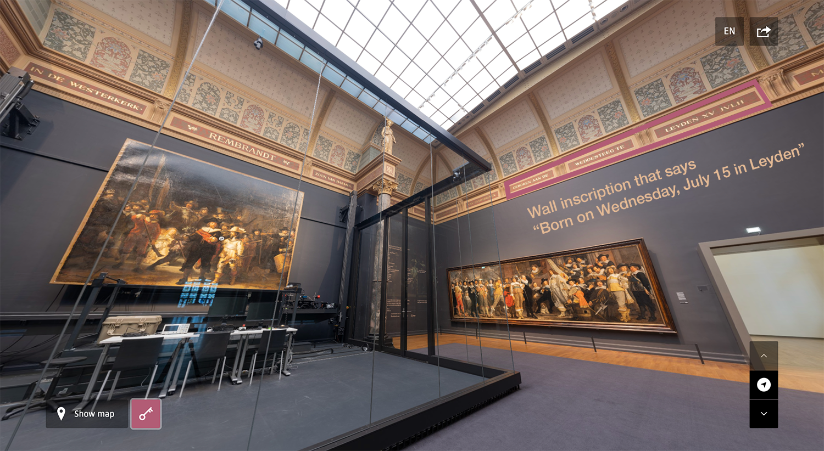

Image 1: Architectural Juxtapositions

If we click on the aforementioned rendition outside of the Challenge mode, the augmentation is expanded: some incidental music invoking the atmosphere is played and multiple buttons appear as audio guide options. Some topics covered are “Highlights tour,” “Present day,” or “Composition,” corresponding to a wide range of potential interests and levels of expertise. Every button brings the user to a completely distinct part of the audio guide narration, thus encouraging non-linear exploration. This is important for two reasons. Firstly, since there is a high volume of information to be learned about just one painting, the user is not faced with an expectation to consume all information at once. Secondly, the museum opens a lot of space for unintentional augmentation as the user can keep coming back to the artwork, and with different environments surrounding them, new connections and observations can be made. The audio guide is not just non-linear, its different parts have intentional placements: they are positioned on the canvas based on their semantics (*Image 2*). For instance, in the “Composition” segment, “Light” and “Depth” options are placed next to the most notable uses of light and depth in the painting. This way, the Rijksmuseum takes advantage of something that would be impossible in a physical museum, reimagining the medium of an audio guide and positioning it in more spatial terms. Benjamin’s constellations theory has a direct application here since curators actively comprehend how different aspects of the painting’s history and meaning can be juxtaposed to one another. The visitor is then invited to join in and select facts and ideas for their own constellation of knowledge and engagement with *The Night Watch.*

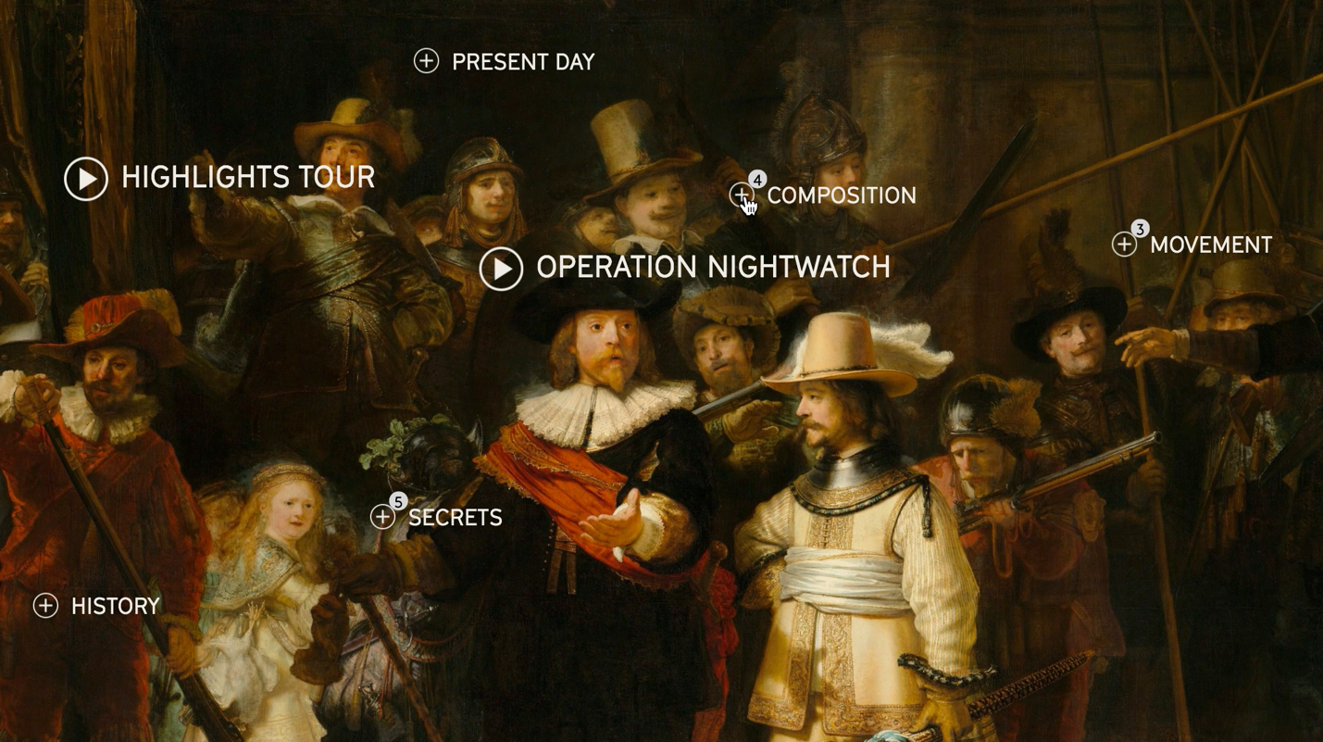

Image 2: Audio Guide Positioning

*The Night Watch* has a special place in the Gallery of Honor and history of art because of its original composition, use of light, and intricate interplay of details. To communicate that through the audio guide, the museum embeds multimedia and uses cinematic montage to establish a certain ethos of attention to detail around *The Night Watch*. In the next few paragraphs, I describe montage techniques that help advance this ethos without an overt presence of a curatorial voice.

When the audio guide talks about the symbolism of how Captain Cocq, the central figure of the ensemble, is portrayed, it shifts from Captain’s costume (where we expect symbolism to be found) to a shadow of his arm (*Image 3*). The shadow is pointing at a place on another man’s suit where we notice the previously mentioned Amsterdam Coat of Arms, an important element to establish the identity of the group portrayed.

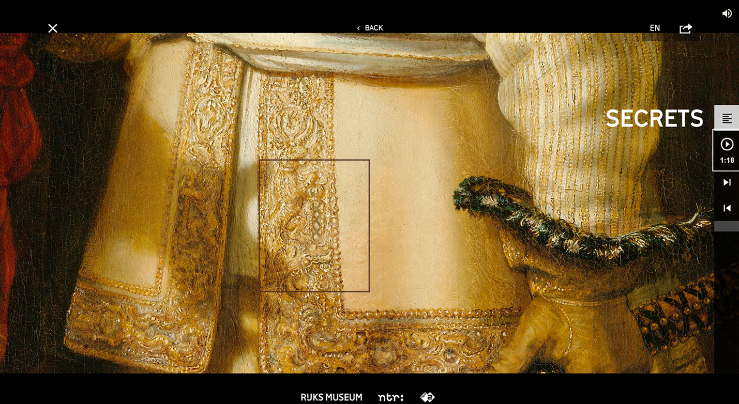

Image 3: The Narrative About Details

This would be impossible to pinpoint without the zooming capabilities of montage. Besides, the museum establishes an expectation of where a secret is meant to be found and then subverts it by cinematically shifting to an alternative location of an answer. This way, the display demonstrates to us the way curators expect us to interact with art: looking holistically and with attention to detail while giving up some degree of control to let accidental findings happen. Implicitly directing visitors’ approach to the artwork this way, the museum hopes to generate the most interest through a discovery mode when the visitor serendipitously discovers interesting elements and patterns.

Our ever-shifting view of the painting underscores its innate dramaturgy and helps the museum attract our attention to the dynamics of a still image. *The Night Watch* belongs to the Baroque, an era in art history characterized by its grandeur, drama, and tension (Britannica, The Editors of Encyclopaedia), which the museum also augments. With a quote from the guide – “Seconds later, it would’ve been a completely different painting,” (“Highlights Tour”, “Movement”, 0:55) – and a linear montage, the museum introduces a way to think about the artwork as a real-life occurrence. Furthermore, similar to the Whitney’s “Sunrise/Sunset” experience that is discussed in the next chapter, the Rijksmuseum adds a time-based rather than a space-based dimension to an online experience. In this vein, another time-based angle occurs to us in the “History” part of the Highlights tour, where we are shown a photograph of a part of the canvas damaged in an acid attack. The photograph is overlaid on top of the recovered version of *The Night Watch*, generating shock value based on how badly it looked before restoration efforts took place.

In the Rijksmuseum’s mediation of internal and external dramaturgy of *The Night Watch*, we see parallels to a “conflict in tempo” and a “conflict between an event and its temporality (achieved by slowing down and speeding up)” that Eisenstein saw as essential to the dynamics of intellectual thought (Somaini 37). These “collisions” and “intervals” exemplary of the intellectual montage are delivered in “Masterpieces Up Close” through the following pacing and weaving techniques: zooming in and out; fading colors in and out to highlight a certain figure; narrowing and expanding the focal point; rapidly shifting between two or more parts of the painting; superimposing external images or geometrical elements to show patterns of composition and lighting; jump-cutting between remote parts of the painting.

The audio guide narration transitions between internal elements and external media by overlaying comparable paintings of pre-modern and modern eras, pop-culture influenced by *The Night Watch*, historical photography, etc. As the guide talks about the artwork’s popularity outside of museum walls, we are shown a Dutch football team posing as the Night Watch militia, the painting’s cameo in a Netflix show *Sense8,* or a special edition of *the Duck Tales* comic featuring its cartoon version. The approach here, as it is in the case of “The Met Unframed” discussed in Chapter I, is to let the visitor “take” the artwork as far outside of museum walls as they wish (Goodman 56). Whether it is finding inspiration for one’s photography, watching a TV show where the painting is being discussed (and thus learning even more about it), or forming an emotional connection with it because of nostalgia for one’s favorite childhood cartoon, the museum opens as many doors to connect to their visitors’ broad range of interests as possible. As this observation demonstrates, the Rijksmuseum does not resist unintentional augmentation but instead fully embraces that their artworks (and media that surround them) do not exist purely for their own sake and deliver external experience, as Bautista would say (10).

Finally, it is important to reiterate the Rijksmuseum’s apparent stance on where “Masterpieces Up Close” falls within their larger augmentation efforts. Since the experience is meant to be interacted with exclusively on the web, we can assume that there is an awareness on the part of the user of the presence of a web browser as a gateway to external sources and information. Therefore, a rapid overlay of content throughout the audio guide narration seems to be encouraging the user to click away from the Rijksmuseum’s website. This allows juxtapositions to happen unintentionally as the user ventures from the content museum controls to the content it does not.

**Chapter III: Configuring New Spatiality**

**Part III.1, The Place and Space of Museum Websites**

There are many parts of “Masterpieces Up Close” that drastically reimagine interactions a user-visitor has with a museum collection. However, one aspect of a centuries-old museum-going procedure remains intact: no part of the visual aesthetic of its space is ultimately left out. If we want to, we still get to see *The Night Watch* as if we are standing in front of it in Amsterdam surrounded by 19th-century architecture. This raises the question: How would we perceive *The Night Watch* in a completely reimagined environment that has little to no resemblance to physical space?

Museum websites have been given a lot of attention in the academic literature by museologists and digital media scholars such as Wilson, Battro, and de Groot. A website is seen as a vehicle of re-contextualizing objects but there is a gap in the analysis of museum websites in terms of their power to recreate or reimagine experiences. Expanding access to wider audiences and researchers is undoubtedly important but it is hard to imagine that this kind of augmentation would have appeal to audiences who do not have a lot of interest from the onset. Since museum websites were historically used as a digital alternative to a brochure or a catalog, it seems that they are still being treated as such, as opposed to their own mode of experience. What certainly does not help is the prominence of “standard” websites and reliance on templates and CMSs (Content Management Systems) (Brinzan), which are often used due to museums’ limited budget and lack of resources to fully explore new media. Most of these templates do not allow for experiential, museum-unique elements; notable exceptions either do not use CMSs at all or seem to have had an entirely different approach to the development process. An example of such exception is a project by the Whitney Museum of American Art’s “Sunrise/Sunset”[19] that makes commissioned art projects appear on the site only during sunrise or sunset.

This web experience augments one of the inseparable aspects of both a museum-going and website-visiting experience – time. The Whitney is putting into question our expectations of timing and pacing when it comes to observing artworks in a museum. For instance, if it is an in-person visit, there are restrictions of when the museum is open, as well as a standard amount of time visitors spend in front of each object (a 2016 study concluded that for most, this time is around 29 seconds per artwork) (Kaplan, “How Long People Look at Art?”). If it is a web museum catalog, its distinction and appeal usually come from ubiquitous access to collections for a non-limited amount of time. The Whitney subverts all of that when it directs the visitor to be on a website at a particular time of the day and only shows an art object for a couple of seconds, recreating the temporality of access and controlling when and how their works are being perceived. This way, “Sunrise/Sunset” simultaneously takes away certain assumptions from both an in-person and a virtual visit while also drawing upon both. Confirming this observation, the museum’s website says that the core of the idea was to “disrupt, replace, or engage with the museum website as an information environment” (Whitney Museum of American Art).

**Part III.2, Timeline, Continents, and Spheres**

What happens when the hyperrealism of “Masterpieces Up Close” meets the reimagined web conventions of “Sunrise/Sunset” while maintaining a juxtaposition-centered approach? This intersection seems to have heavily inspired the British Museum’s collaboration with the Google Cultural Institute (now “Google Arts and Culture”) on “The Museum of the World” interactive experience.[20]

The idea central to interactions with this web application is established at the onset: a loading screen shows a multitude of colorful circles (each representing an object in the actual interface) which “explode” and start forming constellations. With a tagline “History connected” and a clear visual analogy to celestial bodies, it would be natural to assume that makers are referring to Benjamin’s *Arcades Project* findings. Even if this is not the case, I believe that Benjamin’s constellations theory is a great asset to explore layers of augmentation in the British Museum’s curatorial process.

As the graphics are rendered, we are faced with a grey cosmic-looking space and a 3D timeline (*Image 4*). On the x-axis, there are five geographic origins of objects: Africa, Americas, Asia, Europe, and Oceania, all color-coded. Every object that belongs to each region is denoted by a small 3D sphere of the same color and lays on a corresponding part of the x-axis. The y-axis is used for decorative purposes to spread out spheres vertically in case there is a big cluster, since the user’s ability to see these clusters (and realize that certain parts of the timeline are more populated than others) is important to the ideology of this reimagined space. The z-axis denotes the main timeline from 2,000,000 B.C. to 2,000 A.D. and situates object-spheres according to when they were created. The navigation tracks along the z-axis and allows us to travel back-and-forth, seeing objects of all periods.

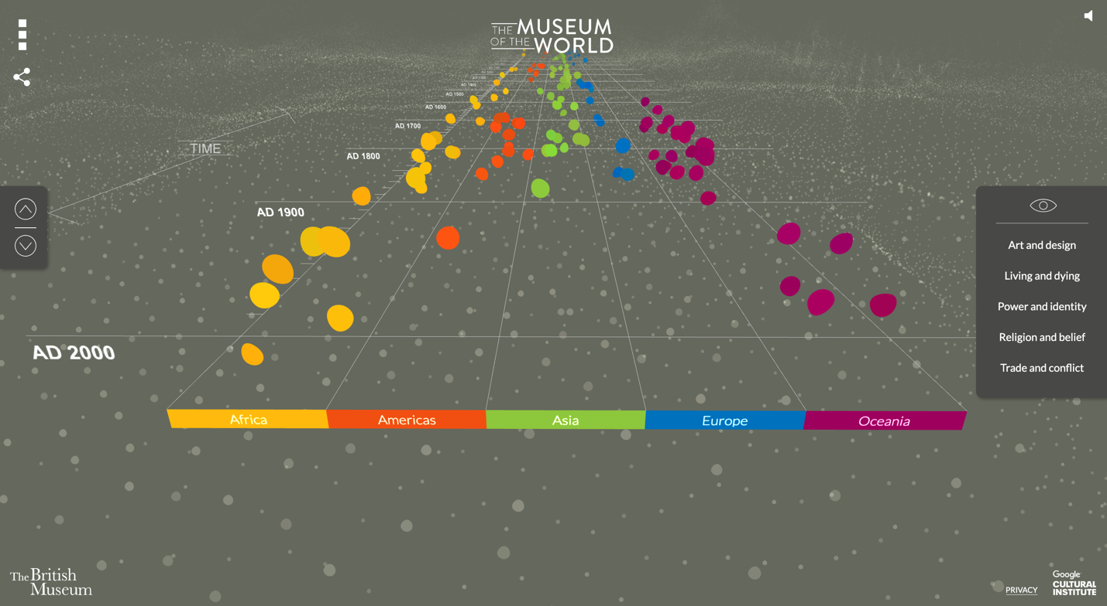

Image 4: Interface of "The Museum of the World"

As in “Masterpieces Up Close,” we are presented with several ways to move through space. The first option is scrolling the timeline, which affords the quickest progression through time and imitates an interaction that we are used to from a familiar medium of a museum website. However, since this feature essentially makes objects advance in our direction in a spaceship-like quality, scrolling also conveys haptics and dynamics of a quick physical movement through the imaginary space. At the same time, there is an option to navigate with front and back arrows, which is more convenient for a slow and controlled exploration of the environment. An additional navigation feature that we did not see in “Masterpieces Up Close” is a filter on the right side of the screen that lets us choose a category of objects we want to explore: “Art and design,” “Living and dying,” “Power and identity,” “Religion and belief,” and “Trade and conflict.”

The way the visitor explores the collection is inherently tied up with augmentation. Before clicking on a sphere, we have neither information nor visual impression of an object. Outside of its period, place of origin, and if the filters are activated, its type, all an object is to us is a colorful sphere with no scale or context. This is a stark contrast to the Rijksmuseum’s model where they expect the user to gain interest based on either visual appeal or recognition, the way it would likely happen in an in-person museum visit. Here, however, with no visual reference to an object the user essentially presses a button akin to Google’s “I’m feeling lucky” and accesses new parts of the collection without a preview or any rationale behind the choice.

Experimentally, the British Museum encourages us to access their collection in a way that would be undesirable within the museum’s physical walls, where we are expected to make educated choices about what parts of the collection to see. With no separators and boundaries between exhibits, we have an unusual opportunity to not only “stumble” upon something we might not have ever approached otherwise but also learn about it with almost no preconceived notion of what it is. There are three main types of re-contextualization and de-contextualization happening during our interactions with the objects. Firstly, even as we learn more information about them, we are in no way affected by their real-life scale; taking away absolute and relative sizes of an object is something that Battro sees as crucial to promote “action and discovery” (146). Secondly, we do not get to see the architectural surroundings of any of the exhibits. This de-contextualization is a rare instance of the British Museum’s confrontation of its imperial ideology that is reflected in the architecture and thus imposed onto the in-person display contextually. Thirdly, the placement of objects is not defined by their popularity or curators’ preferences, and instead, it gets determined by location and date of origin. In lieu of paying attention to one or two popular artworks, we can contemplate networks and relations of tens of smaller ones.

As we click on an object, we still only get a limited glimpse of its properties: its name, more precise place of origin (e.g., a country, territory, dynasty), and a thumbnail image (*Image 5*). Other than that, a constellation spreads before us, visualized with colorful lines drawn between spheres.

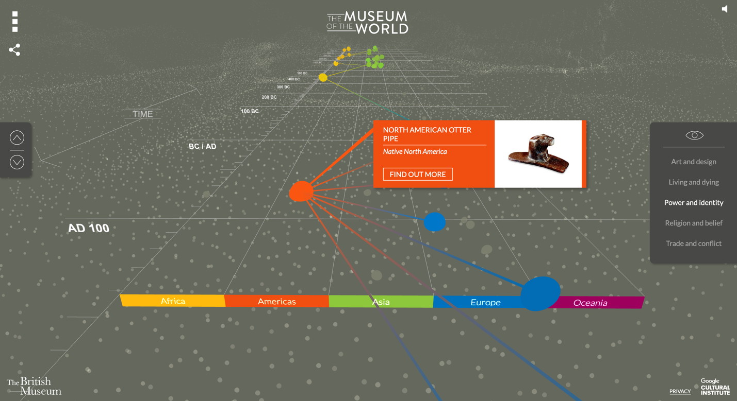

Image 5: A Visual Network of a Clicked Object

Two spheres are considered to have a connection if they belong to the same category (categories are the same as the filters mentioned above). For example, if the user clicks on a sphere-object from the A.D. 0-100 Americas, they learn that it is a “North American Otter Pipe.” Since the pipe used to signify Power and Identity, it gets visually connected to other artifacts that had the same purpose in their time and place. To make sure that we know which properties/filter we are interacting with, a corresponding filter name is highlighted in the panel on the right. Because artifacts that had the same semantics in the same period are explicitly pointed out through these visual constellations, we rapidly juxtapose them, drawing comparisons from their aesthetics, practical usage, etc.

Augmenting their exhibits this way, the British Museum reimagines them as data points to demonstrate and explore historic and geographic patterns. These configurations are notably volatile because of how easy it is to switch from one sphere to another, drawing out a new set of visual constellations. This volatility allows for “sudden clarifications” of meanings to occur (Dillon).

Coming back to an individual object, if we decide to learn more about it based on a limited impression, we can click a “Find out more” button. Even as a larger window with more information shows up, we still do not see an object in the museum space (*Image 6*). Instead, more multimedia augment it in different, non-spatial ways. Other than zooming in on an object, the user can read a detailed description of its history, hear a British Museum curator share their insight about it, or see an embedded Google Maps iframe that shows the exact geographic location where an object is thought to be from. There is also a Related objects category present but it does not engage with juxtapositions quite as much, simply presenting thumbnails of three similar artifacts and not indicating what a relationship/connection is.

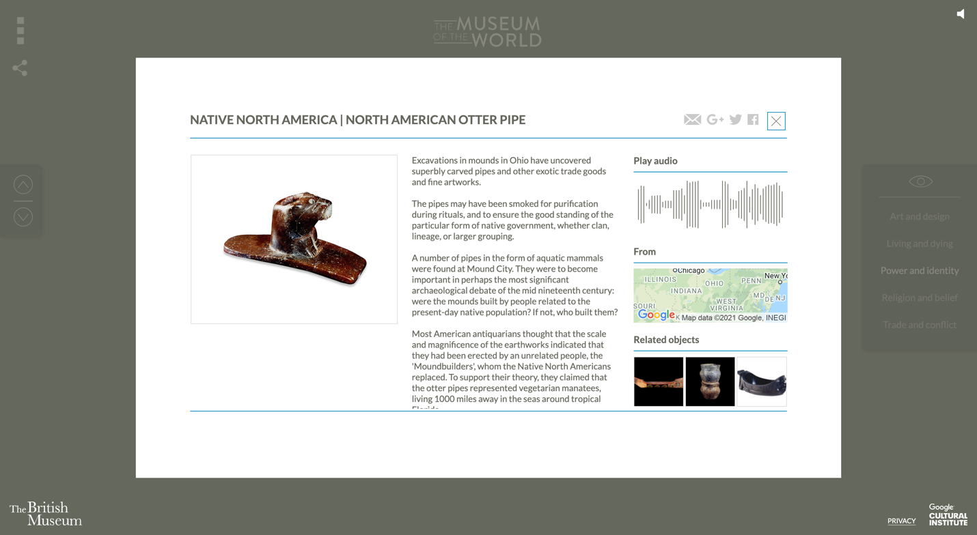

Image 6: Object Details

As we see in both “Masterpieces Up Close” and “The Museum of the World,” when the emphasis is taken off spatial positioning of a museum collection, the curatorial process is focused on *transitions* between parts of an exhibition. In the case of “Masterpieces Up Close,” transitions have been capitalized on through a cinematic montage of different paintings and elements of a single artwork. “The Museum of the World” augmentation is executed in a vastly different manner. Despite “wrapping” each artifact in multimedia from images to maps to other objects, the main value of this online experience lays in the volatility of its constellations of artifacts. Clearly, the mission is not to let the user easily search for something they are already interested in; even if this is not their first time on the webpage, it is hard to replicate a result of the previous visit. But that is, in fact, the point: this digital serendipity is what augments the British Museum’s artifacts in a new way with a removed “authorial perspective” (Dillon). It is relevant to note that when critiquing Benjamin’s theory, Theodor Adorno feared that this approach could present “a view of the world as mere, uninterpreted fact – of material, observable things and unique, unanalyzable events – which the reader would have no reason to connect through any theory at all” (qtd. in Dillon). To this extent, there could be a valid concern that if “The Museum of the World” takes away *too much* context – no space, no surroundings, no size and scale – a visitor could struggle to form interpretations of a set of colorful spheres spread out on a cosmic-looking background. In response to this, museologists like Bautista and Battro would argue that this somewhat radical de-contextualization is exactly what the modern museum needs – with a trust that a visitor, when given more freedom, will always find an edge to the experience that is relevant to them. The debate about the necessity to direct the visitor through the meaning-making of the work, however, could constitute a manuscript of its own and will not be covered comprehensively.

“The Museum of the World” shows that the curatorial attention to transitions and individualized context significantly contributes to the democratization of a museum visit. At the same time, it is important to acknowledge that re-contextualization of artifacts happens selectively and ultimately does not address issues of colonialism and provenance. The self-professed “universal” museum (Kaplan, “The Case Against”), the British Museum constructs a narrative that continues omitting the history of the acquisition of the artifacts even though the format of the experience, with a timeline and locations of origins, presents a context to do so. Therefore, we need to keep in mind that while juxtapositions and montages open up a museum collection to more dynamic interactions with the visitor, they do not automatically resolve Western museums’ problematic heritage. The inventive use of digital media could provide museums with tools of addressing this heritage, which is an interesting and important topic for future research.

**Chapter IV: The Inefficient Augmentation**

So far, I have described experiences in vastly different media forms, from augmented renditions of the physical space to completely imagined domains, covering two extremes of categories from Chapter I. However, what they all have in common is that they successfully position the collection within new internal and external contexts by engaging in juxtapositions and montages. Yet, despite its proclivity to on-the-go montages of content, the digital medium does not guarantee *contextual* augmentation. What this means in practice is that there are experiences that bring a museum object and the information about it into a browser window and sometimes even reimagine it spatially but still fall short of enhancing the visitor experience. This issue was especially prominent at the peak of the COVID-19 pandemic when museums rushed to roll out online interfaces that attempt to easily attract attention with “shiny” attributes and/or try to come as a lower-quality replica of an in-person visit. It is important to clarify that when I talk about inefficient cases of augmentation, I do not imply that these experiences are bad or even completely unattractive to wider audiences. For instance, I would say that 360 VR videos mentioned in Chapter I do not fulfill the mission of digital augmentation since they tend to be limited to non-curated digital renditions. And while I recognize that VR videos are an increasingly popular virtual museum attraction, I would argue that their appeal comes from the novelty of the medium rather than the successful engagement of a visitor.

An all-encompassing example of a resource-heavy interface that does not engage with transitions is a VR exhibition of Jan van Eyck’s work in Ghent’s Museum of Fine Arts. A counterpoise to “Masterpieces Up Close”, this VR rendering attracted my attention with its meticulous attention to recreating aspects of physical space, which is where its main weakness lays. Despite the interface’s aesthetic appeal and an illusion of visitor’s presence, its “social, spatial, temporal and experiential differences” simply prevent it from replicating an in-person visit as it intends (Greenfield). This inadvertently creates a sense of discomfort as the user unsuccessfully attempts to explore the space the way they would do in-person (for example, quickly turning from one exhibit to another).

What is even more important for this work is that the Van Eyck exhibition relies on the smoothness of its medium to deliver some of the contexts. For instance, since it does not augment the look of museum rooms, not superimposing informative text and other media like “Masterpieces Up Close” does, we can only learn about each room by zooming in and reading inscriptions on a wall (*Image 7*). While this is a common way to deliver in-person exhibitions, it is easy to see how a virtual medium could take advantage of having text right in front of the user rather than on a wall surface.

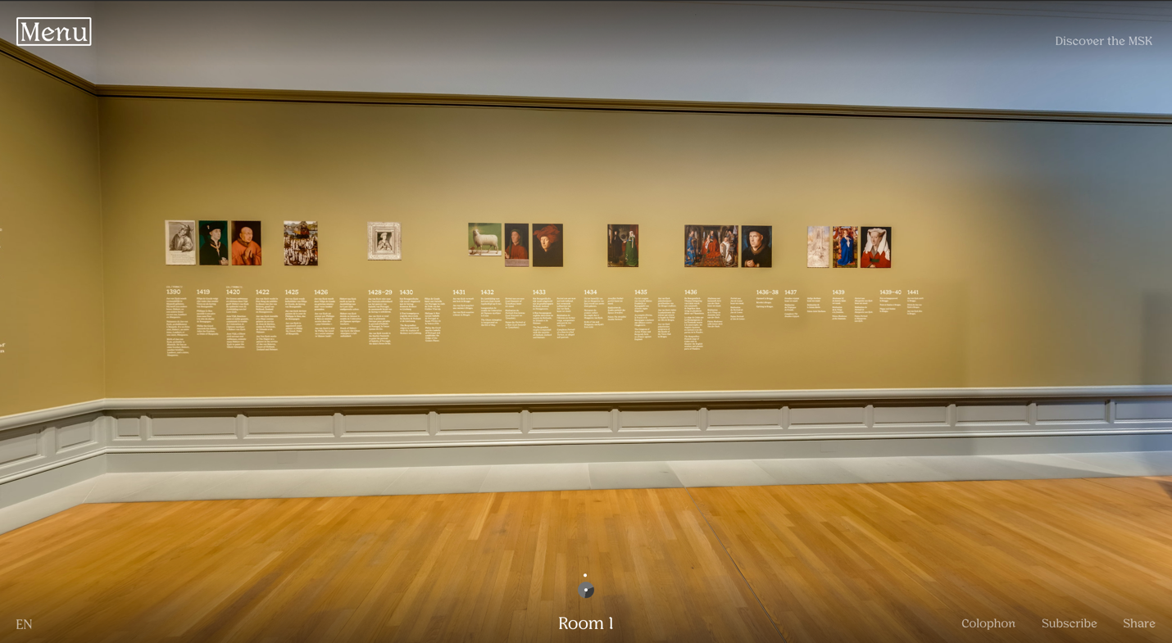Image 7: Text in the Physical Space

Furthermore, since digital media usually afford only reading relevant material, the user is inconvenienced by one description applying to the entire room of objects, and the need to turn the entire interface around to go back to read an inscription. This insistence on staying “faithful” to a visit where impressions of a collection are defined by the physical space is seen in other aspects as well. For instance, while the audio guide does exist, it is not specific to any parts of the tour it is attached to. It provides us with a general context about an object and calls back to an order of a tour as if we walked from one room to another with an audio guide device. This kind of audio guide narration becomes impossible to follow because we “jump” between rooms and exhibits due to how the navigation is set up.

To sum it up, this experience fails to curate intentional augmentation. The multimedia it utilizes fosters linear exploration that is counter-productive to juxtaposing pieces of information, such as two different paintings, artistic elements of one painting, or a painting and its surroundings. Because there is no ethos established regarding transitions in and out of the experience, and not much information is provided (especially visually) on external sources of engagement with artworks, the visitor does not gain an advantage of unintentional augmentation, staying with the experience until they leave it entirely.

**Conclusion**

This study has covered theories of juxtapositions and montages as they apply to browser-based museum experiences. For further research, it would be interesting to see how a framework of transitions in museum collections plays out in other digital museum assets, such as non-experiential websites, social media, audio guide-based AR, etc. Additionally, *online-only* museums and galleries such as the International Museum of Women have been excluded from this study but could present a valuable angle since they rely on digital augmentation to tell the entire story about their collections.

More types of augmentation in online visits have the potential to be studied, such as augmentation of social context. I did not cover an ability to share parts of online tours on social media, cultural capital associated with museums, or their community-building role, all of which can influence and be reinforced through digitization (Bautista 13-21). Other issues that digital augmentation could address, such as museums’ colonial heritage (as demonstrated in Part III.2) and the lack of accessibility to individuals with disabilities, are also subjects for further research.

I believe that the cases of “Masterpieces Up Close” and “The Museum of the World” provide valuable ideas about the democratization of museum spaces through a changing relationship with the visitor. When we feel in charge of our interactions with an artwork, we take on a more participatory stance, seek out aspects we have personal involvement with, and form conclusions based on the range of provided multimedia. This is not to say that the role of a curator and other mediators of the experience is reduced – on the contrary, their touch has to enrich the collection with contexts and themes while remaining largely unnoticeable (Wilson 375-376; Roederer, Revat and Pallud 110). In this sense, an efficiently augmented experience is highly curated to seem uncurated and allow more agency and self-guidance for the visitor.

A definitive qualifier for an efficient digital museum experience is the presence of multiple levels of augmentation, intentional and unintentional. An instance of efficient augmentation does not have to cut down every well-established convention of museum-going at the root – but it must critically engage with it. Every aspect of a spatial organization needs to be re-established in the digital space and kept, modified, or removed depending on how it can help a visitor form personal interest around a collection best.

In my analysis of two efficient web museum experiences in conjunction with one inefficient, four themes describing the application of juxtapositions and montages have emerged.

The first theme is that of juxtapositions/montages of a museum collection with the reimagined space itself. In “Masterpieces Up Close,” we saw the Rijksmuseum displaying the architecture of the Gallery of Honor while intentionally juxtaposing its elements to *The Night Watch* to exemplify the importance of surroundings to the painting’s history. Furthermore, the museum allows parts of the space to appear and disappear on command, demonstrating that the lost “aura” of an in-person visit can be compensated for by uninterrupted access to high-quality visuals. In the case of “The Museum of the World,” the British Museum intentionally excludesspace-related juxtapositions, not forming the context based on size, positioning, or surroundings of an object.

The second theme covers juxtapositions of parts of one object. During the multi-sensorial audio narration of *The Night Watch*, a cinematic montage is used to make unexpected parts of the painting interact with one another. Going far beyond the limitations of human ability, the montage zooms in on certain elements, highlights some, and draws shapes around others to form them into a constellation of small aspects of the artwork one could find interesting. To a lesser extent, internal juxtapositions can be pinpointed in “The Museum of the World” experience, too. As we are interacting with a particular object, its visual representation is put into a contextual constellation with an audio track, a map, and related exhibits.

The third theme covers augmentation on a larger scale, describing juxtapositions/montages of two or more elements of an exhibition. In both objects researched, museums use comparisons, contrasts, and common themes between elements of an experience to create context around them. Best represented by visual constellations of spheres formed on-click in “The Museum of the World,” this approach revolves around helping the visitor to find relevant connections between different objects. A crucial element to delivering these juxtapositions is the navigation that determines speed, pace, and continuity of observation and thus, a montage of different visual elements.

Lastly, the fourth theme looks at the relationship between the entire virtual museum experience and the “outside world.” This theme engages with an idea of unintentional augmentation the most of the four since it essentially juxtaposes an exhibition’s internal narrative with a user’s agenda, personal space, and interests. “Masterpieces Up Close” fulfilled unintentional augmentation through a powerful audio guide montage that kept pointing away from *The Night Watch* to external media such as related history, news, pop-culture, and creations the painting has inspired. This way, instead of resisting the user’s proclivity to leave the virtual Gallery of Honor, the Rijksmuseum suggested ways of researching and thinking about *The Night Watch* that visitors could do on their terms. The British Museum, on the other hand, built the entire “The Museum of the World” experience to have a user “stumble” upon an object, adopting to a dynamic manner we are used to when perceiving content on the web. When the user looks for an artifact to click on as they navigate through constellations of exhibits, they are presented with a limited scope of information. This encourages making choices of what to see based on personal interests rather than perceived importance, and even as a choice is made, continually welcomes external context because of the nature of interactions.

Both “Masterpieces Up Close” and “The Museum of the World” successfully engage with all four themes. What makes them particularly efficient in actualizing museum mission is that they specifically reinvent their material for the digital tour format, contribute to the contextualization of their collections, and embrace the uncertainty of augmentation. Even if they maintain transitions between exhibits that are familiar from an in-person spatial organization, they both utilize affordances of loose-linked digital architecture and, in the case of the Rijksmuseum, get rid of connections to the physical space where necessary. Both museums meticulously curate interactions and narratives but leave enough space for crucial juxtapositions to happen on their own.

This thesis began with an evocation of a rigid structure of the Western museum – but museums also already operate in digital, networked, augmented space, the space of their visitors. Evolving technology and new media provide more tools for meaning-making and search for new modes on one hand, but also introduce even more variables into the museum-visitor relationship that need to be accounted for on the other. The nature of museum is accelerating, and the ways museums will integrate constellations of curatorial intents, collection meanings, social histories, and visitor agencies into their design processes will define its direction.

***Works Cited***

Battro, Antonio. “From Malraux's Imaginary Museum to the Virtual Museum.” *Museums in a Digital Age*, edited by Ross Parry, Routledge, 2010, pp. 136–147.

Bautista, Susanna. *Museums in the Digital Age: changing meanings of place, community, and culture.* AltaMira Press, 2013.

Benjamin, Walter. *The Arcades Project.* Harvard University Press, 1999.

Berger, John. *Ways of Seeing.* Penguin UK, 2008.

Brinzan, Dumitru. “30 Unique Museum Websites Powered by WordPress.” *AcademiaThemes*, 22 Oct. 2020, www.academiathemes.com/2019/30-unique-museum-websites-powered-by-wordpress.

Britannica, The Editors of Encyclopaedia. "Baroque art and architecture". *Encyclopedia Britannica*, 31 Jan. 2021, https://www.britannica.com/art/Baroque-art-and-architecture. Accessed 6 May 2021.

Cooper Hewitt, Smithsonian Design Museum. “Vegetal Chair Chair, 2009.” *Collection Highlights*, collection.cooperhewitt.org/objects/18756101. Accessed 6 Mar. 2021.

de Groot, J. 2010. Historiography and virtuality. In *Culture, Heritage and Representation: Perspectives on Visuality and the Past*, edited by Emma Waterton, Taylor & Francis Group, 2010.*ProQuest Ebook Central*, <https://ebookcentral-proquest->com.proxy.library.nyu.edu/lib/nyulibrary-ebooks/detail.action?docID=4758570.

Diamond, Nina. “The Temple of Dendur: From the Nile to NYC in 360°.” *Metmuseum.org*, 16 June 2016, www.metmuseum.org/blogs/digital-underground/2016/facebook-360-temple-of-dendur.

Dirsehan, Taskin, and Azize Müge Yalçin. “Comparison between Holistic Museum Visitors and Utilitarian Museum Visitors.” *International Journal of Marketing Studies*, vol. 3, no. 4, 2011, doi:10.5539/ijms.v3n4p78.

Dillon, George L. “Montage/Critique: Another Way of Writing Social History.” Postmodern Culture, vol. 14, no. 2, 2004, doi:10.1353/pmc.2004.0005.

Dyer, Geoff. *Ways of Telling: the Work of John Berger*. Pluto Press, 1986.

Eisenstein, Sergei. *Sergei M. Eisenstein: Notes for a General History of Cinema.* Amsterdam University Press, 2016.

Gianatasio, David. “With 'The Met Unframed' From Verizon, the Museum Visits You.” *Muse by Clio*, 19 Jan. 2021, musebycl.io/art/met-unframed-verizon-museum-visits-you. Accessed 16 Mar. 2021.

Glinka, Katrin. “The Process Is Part Of The Solution: Insights from the German Collaborative Project museum4punkt0.” Museum International, 26 Dec. 2018, pp. 92–103., doi: 10.1111/muse.12195.

Goodman, Nelson. “The End of the Museum?” *Journal of Aesthetic Education*, vol. 19, no. 2, 1985, pp. 53–62. JSTOR, [www.jstor.org/stable/3332464. Accessed 18 Oct. 2020](http://www.jstor.org/stable/3332464.%20Accessed%2018%20Oct.%202020).

Grant, Daniel. “Pandemic Pushes Museums Deeper Into Digital Age.” *The Wall Street Journal*, Dow Jones & Company, 31 July 2020, [www.wsj.com/articles/pandemic-pushes-museums-further-into-digital-age-11596196801](http://www.wsj.com/articles/pandemic-pushes-museums-further-into-digital-age-11596196801).

Greenfield, Adam. *Radical Technologies: The Design of Everyday Life.* Verso, 2018.

Hediger, Vinzenz. *Notes for a General History of Cinema*, by Sergei Eisenstein, Amsterdam University Press, 2016, pp. 347–356.

Kaplan, Isaac. “How Long Do People Really Spend Looking at Art in Museums?” *Artsy*, 7 Nov. 2017, [www.artsy.net/article/artsy-editorial-long-people-spend-art-museums. Accessed 2 Mar. 2021](http://www.artsy.net/article/artsy-editorial-long-people-spend-art-museums.%20Accessed%202%20Mar.%202021).

---. “The Case Against the Universal Museum.” *Artsy*, 27 Apr. 2016, www.artsy.net/article/artsy-editorial-the-case-against-the-universal-museum.

Kirshenblatt-Gimblett, Barbara. “The Museum--A Refuge for Utopian Thought”, 2020. ResearchGate, <https://www.researchgate.net/publication/242493603_The_Museum--A_Refuge_for_Utopian_Thought>.

König Galerie. “Exercise in Hopeless Nostalgia - World Wide Webb.” *König Digital*, 2020, [www.koeniggalerie.com/exhibitions/30644/exercise-in-hopeless-nostalgia-world-wide-webb](http://www.koeniggalerie.com/exhibitions/30644/exercise-in-hopeless-nostalgia-world-wide-webb).

Kolesárová, Lucia. “Designing For The Tactile Experience.” *Smashing Magazine*, 2 Apr. 2018, [www.smashingmagazine.com/2018/04/designing-tactile-experience/](http://www.smashingmagazine.com/2018/04/designing-tactile-experience/).

Mohammed-Amin, Rozhen. “Augmented Experiences: What can Mobile Augmented Reality Offer Museums and Historic Sites?”, University of Calgary (Canada), Ann Arbor, 2015. ProQuest, <http://proxy.library.nyu.edu/login?url=https://www-proquest-com.proxy.library.nyu.edu/docview/1754628740?accountid=12768>.

Olivares, Alexandra, and Jaclyn Piatak. “Exhibiting Inclusion: An Examination of Race, Ethnicity, and Museum Participation.” *VOLUNTAS: International Journal of Voluntary and Nonprofit Organizations*, 2021, doi:10.1007/s11266-021-00322-0.

Romano, Andrea. “Stuck at Home? These 12 Famous Museums Offer Virtual Tours You Can Take on Your Couch.” *Travel + Leisure*, 12 Mar. 2020, [www.travelandleisure.com/attractions/museums-galleries/museums-with-virtual-tours](http://www.travelandleisure.com/attractions/museums-galleries/museums-with-virtual-tours).

Ross, Nathan. "Walter Benjamin’s First Philosophy: Towards a Constellational Definition of Experience" *Open Philosophy*, vol. 3, no. 1, 2020, pp. 81-101. <https://doi.org/10.1515/opphil-2020-0006>

Roederer, Claire, Robert Revat, and Jessie Pallud. "Does Digital Mediation really Change the Museum Experience? Museomix in the Lyon-Fourvière Archaeological Museum." International Journal of Arts Management, vol. 22, no. 3, 2020, pp. 108-123. ProQuest, <http://proxy.library.nyu.edu/login?url=https://www-proquest-com.proxy.library.nyu.edu/docview/2433294566?accountid=12768>.

Smith, Lilly. “Stuck at Home Because of Coronavirus? How to Get Your Art and Design Fix from Your Couch.” *Fast Company*, Fast Company, 16 Mar. 2020, www.fastcompany.com/90475447/stuck-at-home-because-of-coronavirus-how-to-get-your-art-and-design-fix-from-your-couch. Accessed 15 Mar. 2021.

Somaini, Antonio. *Notes for a General History of Cinema*, by Sergei Eisenstein, Amsterdam University Press, 2016, pp. 19–109.

Whitney Museum of American Art. “Sunrise/Sunset.” *Art & Artists*, whitney.org/artport/commissions/sunrise-sunset. Accessed 6 Feb. 2021.

Wilson, Ross J. "Behind the scenes of the museum website." Museum Management and Curatorship 26.4, 2011, pp. 373-389.

Zielinski, Siegfried, and Gloria Custance. *Audiovisions: Cinema and Television as Entr'actes in History*. Amsterdam University Press, 1999. *JSTOR*, www.jstor.org/stable/j.ctt45kfjs. Accessed 6 May 2021.

"augment." *Merriam-Webster.com*. Merriam-Webster, 2021. Web. Accessed 3 Jan. 2021.

“10 Museums You Can Explore Right Here, Right Now.” *Google Arts & Culture*, artsandculture.google.com/story/igKSKBBnEBSGKg?hl=en. Accessed 2 Mar. 2021.

***Appendix: Links to Museum Experiences***

“Masterpieces Up Close”, The Rijksmuseum, <https://www.rijksmuseum.nl/en/masterpieces-up-close>

“The Museum of the World”, The British Museum with Google, <https://britishmuseum.withgoogle.com/>

Google Arts & Culture Street View, National Museum of Modern and Contemporary Art, Korea with Google, <https://artsandculture.google.com/partner/national-museum-of-modern-and-contemporary-art-korea?hl=en>

Google Arts & Culture Street View, MASP - Museu de Arte de São Paulo Assis Chateaubriand with Google, <https://artsandculture.google.com/partner/masp?hl=en>

Virtual Tours “Enjoy the Louvre at home!”, The Louvre, <https://www.louvre.fr/en/online-tours>

Van Eyck Tour, Museum of Fine Arts Ghent, <https://virtualtour.vaneyck2020.be/en/adults/room-1/room-0-1>

“The Met 360º Project”, The Metropolitan Museum of Art, <https://www.metmuseum.org/art/online-features/met-360-project>

“The Met Unframed”, The Metropolitan Museum of Art with Verizon, <https://themetunframed.com/closed>

“Exercise in Hopeless Nostalgia – World Wide Webb”, König Galerie, <https://webb.game/>

Collection Highlights, Cooper Hewitt Smithsonian Design Museum, <https://collection.cooperhewitt.org/>

“Explore the Hermitage”, The State Hermitage Museum, <https://www.hermitagemuseum.org/wps/portal/hermitage/explore/highlights?lng=en>

“Sunrise/Sunset”, Whitney Museum of American Art, <https://whitney.org/artport/commissions/sunrise-sunset>

“Art & Artists”, Walker Art Center, <https://walkerart.org/collections/browse>

“Viennese Modernism”, Vienna Now | Forever, <https://modernism.vienna.info/en>

“Sophie Taeuber-Arp”, The Museum of Modern Art (MoMA) with Google, <https://artsandculture.google.com/exhibit/sophie-taeuber-arp/swKioHNhYqZoLw>

“Fashioning a Nation”, National Gallery of Art, <https://artsandculture.google.com/exhibit/fashioning-a-nation/ggJCDunxd5wXLw?hl=en>

1. <https://www.rijksmuseum.nl/en/masterpieces-up-close>
2. <https://britishmuseum.withgoogle.com/>
3. <https://micr.io/>
4. <https://artsandculture.google.com/partner/national-museum-of-modern-and-contemporary-art-korea?hl=en>
5. <https://artsandculture.google.com/partner/masp?hl=en>
6. <https://www.louvre.fr/en/online-tours>
7. <https://virtualtour.vaneyck2020.be/en/adults/room-1/room-0-1>
8. <https://www.metmuseum.org/art/online-features/met-360-project>
9. <https://themetunframed.com/closed>
10. <https://webb.game/>
11. <https://collection.cooperhewitt.org/>
12. <https://www.hermitagemuseum.org/wps/portal/hermitage/explore/highlights?lng=en>
13. <https://whitney.org/artport/commissions/sunrise-sunset>
14. <https://walkerart.org/collections/browse>
15. <https://modernism.vienna.info/en>
16. <https://artsandculture.google.com/exhibit/sophie-taeuber-arp/swKioHNhYqZoLw>
17. <https://artsandculture.google.com/exhibit/fashioning-a-nation/ggJCDunxd5wXLw?hl=en>
18. <https://www.rijksmuseum.nl/en/masterpieces-up-close>
19. <https://whitney.org/artport/commissions/sunrise-sunset>
20. <https://britishmuseum.withgoogle.com/>